SOLUTION ARCHITECTURE

Project Title | News Tracker Application
Team ID | PNT2022TMID05721
Team Members | Shivani.N  Akarshan.S  Surya Narayanan.R.U  Venkat Sowmya.R

A Solution Architecture
- Find the best tech solution to solve existing business problems.
- Describe the structure, characteristics, behavior, and other aspects of the software to project stakeholders.
- Define features, development phases, and solution requirements.
- Provide specifications according to which the solution is defined, managed, and delivered.

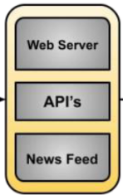
Database with real-time news content
Internet
Topic Listing
Region based news contents
Article Summary
Providing truthness rating
Response
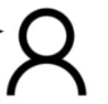
Request
End User

